Machine Learning for The Preliminary Diagnosis of Dementia
Fubao Zhu, PhD¹, Xiaonan Li, BS¹, Haipeng Tang, MS², Zhuo He, BS², Chaoyang Zhang, PhD², Guang-Uei Hung³, MD, Pai-Yi Chiu, MD, PhD⁴, Weihua Zhou, PhD²
¹School of Computer and Communication Engineering , Zhengzhou University of Light Industry, Zhengzhou, Henan
²School of Computing Sciences and Computer Engineering, University of Southern Mississippi, Hattiesburg, MS
³Department of Nuclear Medicine, Show Chwan Memorial Hospital, Changhua, Taiwan
⁴Department of Neurology, Show Chwan Memorial Hospital, Changhua, Taiwan
*Corresponding authors:
Pai-Yi Chiu, MD, PhD
Department of Neurology, Show Chwan Memorial Hospital, Changhua, Taiwan
E-mail: paiyibox@gmail.com
Weihua Zhou, PhD
School of Computing, University of Southern Mississippi, Long Beach, MS 39560
E-Mail: weihua.zhou@usm.edu

Abstract
Objective: The reliable Diagnosis remains a challenging issue in the early stages of dementia. We aimed to develop and validate a new method based on machine learning to help doctors accurately screen normal, mild cognitive impairment (MCI), very mild dementia (VMD), and dementia using informant-based questionnaire.
Methods: we enrolled 5,272 individuals who were required to fill out all the questions on a 45-item questionnaire. They were randomly divided into a training set (4,745 participants) and a test set (527 participants). We first compared three different techniques of feature selection (Random Forest, Information Gain, and Relief) in order to select the most important features. Then, the top features combined with six classification algorithms( Random Forest, AdaBoost, LogitBoost, Neural Network, Naive Bayes, and Support Vector Machine ), were used to develop the diagnostic models. The models' training and parameter optimization were done by 5-fold cross-validation. We then evaluated each diagnostic model in the test set using Accuracy, Precision, Recall, and F-measure.
Results: There are significant performance differences among these three feature selection methods. Random Forest is the most effective among them, and it effectively improves the overall performance of all diagnostic models. In the classification models, Naive Bayes algorithm performs the best (Accuracy=0.81, Precision=0.82, Recall=0.81, and F-measure=0.81) among the six models; it shows good results for normal (Sensitivity=0.84, Specificity=0.94), MCI (Sensitivity=0.62, Specificity=0.93), VMD (Sensitivity=0.72, Specificity=0.93), and dementia (Sensitivity=0.92, Specificity=0.95).
Conclusion: The diagnostic model proposed in this paper provides a powerful tool for clinicians to diagnose the early stages of dementia.
Keywords: Dementia, Feature selection, Random Forest, AdaBoost, Naive Bayes.

1 Introduction
Alzheimer's disease (AD) and other dementias that occur most frequently in older adults are heavy burdens on families and society due to their highly intellectual disability. To date, there is no effective treatment to slow down or stop the progression of dementia. It is critical to focus on the early stages, timely intervention and delay of the disease. The clinical diagnosis of dementia is based on the detailed medical history provided by patients and their families, neurological examination, and neuropsychological tests. Other tests including hematology, CT, and MRI should be performed to rule out other causes of dementia. Neuropsychological tests play a crucial role in detecting dysfunctions in human “cognitive domains”. Even though there have been some clinical measures for the early diagnosis of dementia, a lot of subjectivity still exists [1-6]. It is of great importance to developing better diagnostic tools.

Accurate classification of cognitive impairment is not only beneficial to individuals but also important for medicine. In clinical diagnosis, it is time intensive for the manual diagnosis of cognitive impairment, which may require multiple pieces of information like a neuropsychological test score, laboratory study results, knowledgeable informant reports and so on. The efficiency and accuracy of the diagnosis are determined by the professional level of the practitioner. In some remote areas lacking professional personnel, it will be a much more difficult task for classification and the early diagnosis of dementia. Machine Learning (ML) is an advanced computing technology which can improve the analysis of medical data and automatically make the diagnostic decision [7].

The aims of the paper were (1) to optimize or even reduce the number of neuropsychological tests used to classify dementia patients by using feature selection algorithms and (2) to develop and validate an accurate classification model based on the diagnostic information of 5272 clinically distinct subjects.
2 Materials and Methods
Figure 1 shows the workflow of our method. The dataset was first randomly split into a training dataset and a test dataset. Feature selection, model optimization, and cross-validation were applied into the training data to develop and optimize the diagnosis models. Finally, the models were tested with the test data to find the optimal diagnosis model.
2.1 Participant
5,272 patients were enrolled from three centers, of whom 379 were normal, 1,347 were MCI, 816 were VMD, and 2,730 were dementia. They were randomly divided into a training set (4,745 participants) to build the diagnostic models and an independent test set (527 participants) to validate the diagnostic models in discriminating normal, MCI, VMD, and dementia. In the training set, there were 328 for normal, 1,234 for MCI, 718 for VMD, and 2,465 for dementia. In the test set, there were 51 for normal, 113 for MCI, 98 for VMD, and 265 for dementia. In the diagnosis of cognitive disorders, neurosurgeons interviewed the study subjects through a standardized neurological examination, and historical inquiry fully grasped the subject's memory complaints and clinical manifestations and completed the CDR score. A diagnostic team was composed of physicians in the neurology department of cognitive impairment. The results of the neurological examination, history, and neuropsychological tests of each study were evaluated. Finally, the diagnosis was given. Informed consent has been received from all participants.
2.2 Feature selection
In machine learning, the 45 features have potentially possessed different importance in the diagnosis of dementia. Feature selection can effectively eliminate redundant and/or unrelated features. On the one hand, it can improve the generalization performance and efficiency of the machine learning algorithm; on the other hand, it can simplify the procedure of diagnosis and enhance the practicality in the clinic. In this section, we explored three feature selection methods, which are Random Forest, Information Gain, and Relief [8-13].
2.2.1 The Random Forest algorithm for feature selection
We can use the Random Forest model to filter features and get their correlation with classification. Due to the inherent randomness of Random Forest, the model may give a different weight of importance each time. However, when training the model for several runs, in each run we select a certain amount of characteristics and retain the intersection between the new feature set and the set of features selected in other runs; After a certain number of runs, we can finally get a certain amount of features that have important contributions to the classification task. This method was implemented in the machine-learning software package Python.

2.2.2 The Information Gain algorithm for feature selection
Information Gain is an effective method for feature selection. In the Information Gain, the criterion is to measure how much information the feature can bring to the classification model, and the more information it brings, the more significant it is. Information Gain is based on the theory of entropy, which has been widely used by researchers in various application scenarios. We used the Information Gain algorithm implemented in Weka, which is a powerful open-source Java-based machine learning workbench. Based on Information Gain score, the features with score values below a threshold were filtered out.

2.2.3 The Relief algorithm for feature selection
The core idea of Relief is that a good feature should make the eigenvalues of the nearest neighbor samples be the same or similar, and make the values between different classes of nearest neighbors differ or differ greatly. The advantages of Relief algorithm are high operation efficiency, no restriction on data type, and insensitivity to relations among features. The drawback of Relief algorithm is that, unlike many feature evaluation algorithms, such as Information Gain, Gini-Index, the Relief algorithm cannot remove redundant features, and the algorithm will give all kinds of high correlation features, regardless of whether the feature is redundant with other features. We used the implementation of Relief algorithm available on Weka.
2.3 Construction of the diagnostic models
We examined six different classification algorithms to build the diagnostic models, including Random Forest, AdaBoost, LogitBoost, Neural Network (NN), Naive Bayes, and Support Vector Machine (SVM). To optimize the corresponding model parameters and to estimate the performance, we used the Scikit-learn Python toolbox and the experimental mode (Experimenter) in Weka, which allows large-scale experiments to run with results stored in a database for later retrieval and analysis. Moreover, the Accuracy, Precision, Recall, and F-measure as performance metric were computed to evaluate the diagnostic models using the test set. The diagnostic models’ training and parameter optimization were done by 5-fold cross-validation (CV).

Random Forest is a classifier with multiple decision trees, in which the output is determined by a majority vote of the trees. It is not sensitive to noise or overtraining, because resampling is not based on weighting. It has relatively high Accuracy and computational efficiency. AdaBoost and LogitBoost are boosting algorithms in which the key idea is to train different classifiers (weak classifiers) for the same training set, and then combine these weak classifiers to form a stronger final classifier (strong classifier). We used the Multilayer Perceptron (MLP) as an NN implementation, which is a forward-structured artificial Neural Network that maps a set of input vectors to a set of output vectors. Naive Bayesian is a classification method based on Bayes' theorem and characteristic condition independent hypothesis. SVM searches for the best separated hyperplane as the maximum marginal hyperplane to solve the problem of multiclass classification,
3 Results
3.1 Feature selection
Feature ranking. Figure 2 shows the features ranking. (a) shows the features ordered by their rank score in the Information Gain algorithm, and (b) shows the features ordered by their rank score in the Relief algorithm.
Features selection. Figure 3 shows the top 15 features selected according to the feature selection algorithm. The top 15 features selected by the three feature selection algorithms are different. Among the features selected by the random forest, there have 5 features common with the features by the Information Gain, 4 features common with those by Relief, and 2 features common with those by Information Gain. Among the features selected by Information Gain, there have 12 features common with those by Relief.
3.2 Optimization of diagnostic models
The optimal model parameters are shown in Table 1. The default parameters of the algorithm are not displayed.

3.3 Evaluation of performance
Table 2 shows the classification performance of six algorithms under three feature selections. Accuracy, Precision, Recall, and F-measure are reported. The Naive Bayes algorithm performs the best (Accuracy=0.81, Precision=0.82, Recall=0.81, and F-measure=0.81) among the six classification models，followed by the Random Forest （Accuracy=0.783, Precision=0.79, Recall=0.78, and F-measure=0.78）and LogitBoost algorithm (Accuracy=0.787, Precision=0.78, Recall=0.79, and F-measure=0.78).
Table 3 shows the results of normal, MCI, VMD, and dementia by the six the classification models. The Naive Bayes algorithm shows good results for normal (Sensitivity=0.84, Specificity=0.94), MCI (Sensitivity=0.62, Specificity=0.93), VMD (Sensitivity=0.72, Specificity=0.93), and dementia (Sensitivity=0.92, Specificity=0.95).

4 Discussion
The purpose of this study was to provide solutions based on machine learning to support classification and the early diagnosis of dementia. Although some studies have constructed diagnostic models, to our knowledge, current screening tools have great limitations when being applied to multi-classification and class imbalance problems [14-18]. We carried out a sensitivity analysis for testing the robustness of the results by our classification algorithms. Our results showed that, in feature selection, Random Forest performs the best than the other two feature selection algorithms in the six classification models. Random Forest as a feature selection algorithm makes the rare classes (normal) easy to classify correctly. Among the classification models, the Naive Bayes algorithm performs the best, followed by the Random Forest and LogitBoost algorithm.

Williams et al [2] employed SVM, Decision Tree, Neural Network and Naïve Bayes for screening normal, MCI, VMD, and dementia and found that the Naïve Bayes showed the best accuracy of 83.1%. In our work, the Naïve Bayes showed the accuracy of 80.1%. Bansal et al [5] compared the performance of four machines learning algorithms, J48, Naive Bayes, Random Forest, and Multilayer Perceptron in detecting dementia. J48 showed the best accuracy of 99.52% for the detection of dementia; however, since fewer samples were collected in their study, the results still require further validation and testing. Seixas et al [19] proposed a Bayesian Network decision model for screening dementia, dementia due to AD and MCI. The Bayesian Network showed the best results for dementia (0.94) and MCI (0.92) when using F1-score as the evaluation metric, much higher than the F1-score (62%–74%) in our classification for MCI. Battista et al [20] explored the role of the amount of neuropsychological measures to predict subjects with normal, mild, severe impairment, or dementia. They used the feature reduction strategies and finally selected the top 10 features from 131 measures; SVM showed the best classification performance (Accuracy, Sensitivity, and Specificity>0.89) when discriminating subjects with moderate dementia from normal subjects. In our study, Random Forest was the most effective for feature selection, which selected the top 15 features from 45 measures; among six diastoic mdels, the Naive Bayes algorithm performed the best for overall classifiaction, and it showed good results for identifying each class as well.

Class imbalance exists in many real-world decision making problems. In this paper, the ensemble learning technique used in Random Forest, AdaBoost, and LogitBoost can increase the accuracy of a single classifier by combining the classification results from different trained classifiers; it has been demonstrated to increase the performance when processing the imbalance problem [21]. Naïve Bayes classifier deals with class imbalance naturally by multiplying the likelihood by the class prior probability. In SVM, the classes with fewer samples have higher misclassification penalty, which can alleviate the imbalance. Nevertheless, the accuracy of our diagnostic model still remains scope for improvement. Our future work will further explore sampling techniques and classification algorithms to improve our diagnostic model.

5 Limitations
The study was conducted in only three hospitals in Taiwan, which may arise selection bias. More medical centers and subjects are needed to validate our method further.

6 Conclusions
We developed and validated new approaches to screening normal, MCI, VMD, and dementia. As a result, Random Forest is the most effective for feature selection among the three feature selection methods, and it improves the overall performance of all diagnostic models. Among the six classification models, the Naive Bayes algorithm performs the best (Accuracy=0.81, Precision=0.82, Recall=0.81, and F-measure=0.81); it shows good results for identifying normal (Sensitivity=0.84, Specificity=0.94), MCI (Sensitivity=0.62, Specificity=0.93), VMD (Sensitivity=0.72, Specificity=0.93), and dementia (Sensitivity=0.92, Specificity=0.95).

References:
- N. Amoroso et al., Deep learning reveals Alzheimer’s disease onset in MCI subjects: Results from an international challenge. Journal of Neuroscience Methods. 302, 3–9 (2018).
- J. A. Williams, A. Weakley, D. J. Cook, M. Schmitter-edgecombe, Machine Learning Techniques for Diagnostic Differentiation of Mild Cognitive Impairment and Dementia, 71–76 (2013).
- D. P. D. M. P. W. Shankle W.R., Improving dementia screening tests with machine learning methods. Alzheimer’s Research. 2, 95–99 (1996).
- A. Rong Chen, Machine-learning techniques for building a diagnostic model for very mild dementia. 52, 234–244 (2011).
- D. Bansal, R. Chhikara, K. Khanna, P. Gupta, Comparative Analysis of Various Machine Learning Algorithms for Detecting Dementia, in Procedia Computer Science(Elsevier B.V., 2018), vol. 132, pp. 1497–1502.
- P. Vemuri et al., Alzheimer’s disease diagnosis in individual subjects using structural MR images: Validation studies. NeuroImage. 39, 1186–1197 (2008).
- X. Liu et al., Use of multimodality imaging and artificial intelligence for diagnosis and prognosis of early stages of Alzheimer’s disease. Translational Research. 194(2018), pp. 56–67.
- L. Yin, Y. Ge, K. Xiao, X. Wang, X. Quan, Feature selection for high-dimensional imbalanced data. Neurocomputing. 105, 3–11 (2013).
- G. Menardi, N. Torelli, Training and assessing classification rules with imbalanced data. Data Mining and Knowledge Discovery. 28, 92–122 (2014).
- B. Krawczyk, M. Woźniak, G. Schaefer, Cost-sensitive decision tree ensembles for effective imbalanced classification. Applied Soft Computing Journal. 14, 554–562 (2014).
- S. Maldonado, R. Weber, F. Famili, Feature selection for high-dimensional class-imbalanced data sets using Support Vector Machines. Information Sciences. 286, 228–246 (2014).
- Z. Sun et al., A novel ensemble method for classifying imbalanced data. Pattern Recognition. 48, 1623–1637 (2015).
- C. K. Maurya, D. Toshniwal, Large-Scale Distributed Sparse Class-Imbalance Learning. Information Sciences. 456, 1–12 (2018).
- M. Buscema et al., An improved I-FAST system for the diagnosis of Alzheimer’s disease from unprocessed electroencephalograms by using robust invariant features. Artificial Intelligence in Medicine. 64, 59–74 (2015).
- R. Craig-Schapiro et al., Multiplexed immunoassay panel identifies novel CSF biomarkers for alzheimer’s disease diagnosis and prognosis. PLoS ONE. 6(2011), doi:10.1371/journal.pone.0018850.
- S. Li et al., Hippocampal shape analysis of Alzheimer disease based on machine learning methods. American Journal of Neuroradiology. 28, 1339–1345 (2007).
- J. M. Guerrero, R. Martínez-Tomás, M. Rincón, H. Peraita, Bayesian Network Model to Support Diagnosis of Cognitive Impairment Compatible with Early Diagnosis of Alzheimer’s Disease. Methods of Information in Medicine. 55, 42–49 (2015).
- M. A. Hall, G. Holmes, Benchmarking attribute selection techniques for discrete class data mining, IEEE Trans Knowledge Data Eng. 15, 1437–1447 (2003).
- F. L. Seixas, B. Zadrozny, J. Laks, A. Conci, D. C. Muchaluat Saade, A Bayesian network decision model for supporting the diagnosis of dementia, Alzheimer׳s disease and mild cognitive impairment. Computers in Biology and Medicine. 51, 140–158 (2014).
- P. Battista, C. Salvatore, I. Castiglioni, Optimizing neuropsychological assessments for cognitive, behavioral, and functional impairment classification: A machine learning study. Behavioural Neurology.2017(2017), doi:10.1155/2017/1850909.
- M. Galar, A. Fernández, E. Barrenechea, H. Bustince, F. Herrera, A review on ensembles for the class imbalance problem: bagging-, boosting-, and hybrid-based approaches. IEEE Trans. Syst. Man Cybern. Part C 42(4), 463–484 (2012)

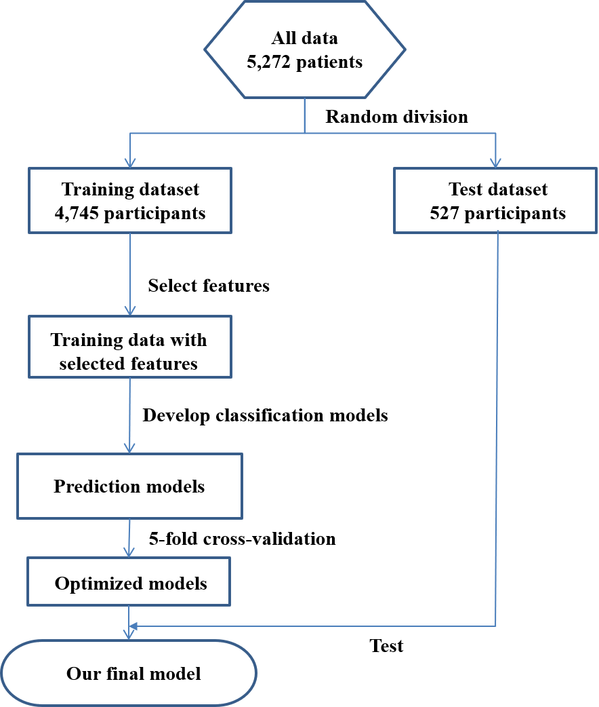
Fig.1. The workflow of data processing in our method to develop and validate the diagnosis model.

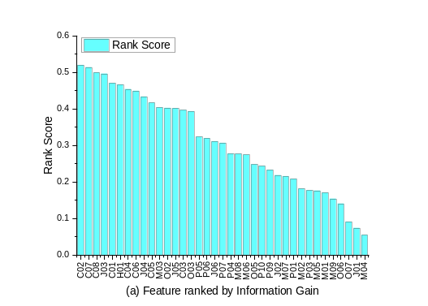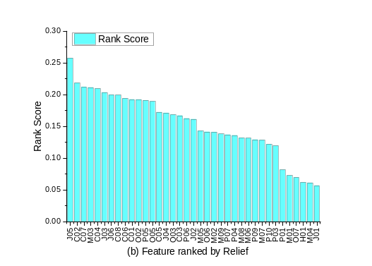
Fig.2. Feature ranking by Information Gain and Relief algorithm.

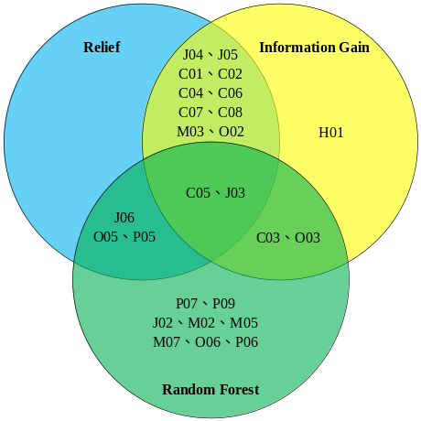
Fig.3. The top 15 features selected by Random Forest, Information Gain, and Relief algorithm
Table 1. The corresponding model parameters
Algorithm | model parameters | value
Random Forest | class_weight | balanced
Random Forest | max_depth | 20
Random Forest | n_estimators | 20
Random Forest | random_state | 2018
AdaBoost | class_weight | balanced
AdaBoost | base_estimator | Logistic Regression
AdaBoost | algorithm | SAMME
AdaBoost | n_estimators | 10
AdaBoost | random_state | 2018
LogitBoost | Classifier-maxDepth | RandomForest-5
Multilayer Perceptron | hidden_layer_sizes | 3
Multilayer Perceptron | random_state | 2018

Table 2. Overall performance of the diagnostic model in all classification models. Results were obtained using the features selection.
Algorithm | Feature selection | Accuracy | Precision | Recall | F-measure
Random Forest | Relief | 0.781 | 0.8 | 0.78 | 0.78
Random Forest | Information Gain | 0.783 | 0.79 | 0.78 | 0.78
Random Forest | Random Forest | 0.757 | 0.77 | 0.76 | 0.76
AdaBoost | Relief | 0.774 | 0.78 | 0.77 | 0.77
AdaBoost | Information Gain | 0.774 | 0.78 | 0.77 | 0.77
AdaBoost | Random Forest | 0.761 | 0.76 | 0.76 | 0.76
LogitBoost | Relief | 0.798 | 0.75 | 0.80 | 0.76
LogitBoost | Information Gain | 0.783 | 0.73 | 0.78 | 0.74
LogitBoost | Random Forest | 0.787 | 0.78 | 0.79 | 0.78
Multilayer Perceptron | Relief | 0.805 | 0.75 | 0.80 | 0.76
Multilayer Perceptron | Information Gain | 0.789 | 0.73 | 0.79 | 0.75
Multilayer Perceptron | Random Forest | 0.776 | 0.76 | 0.78 | 0.76
Naïve Bayes | Relief | 0.786 | 0.74 | 0.79 | 0.75
Naïve Bayes | Information Gain | 0.810 | 0.82 | 0.81 | 0.81
Naïve Bayes | Random Forest | 0.810 | 0.82 | 0.81 | 0.81
SVM | Relief | 0.797 | 0.74 | 0.80 | 0.76
SVM | Information Gain | 0.791 | 0.73 | 0.79 | 0.75
SVM | Random Forest | 0.763 | 0.74 | 0.76 | 0.75
Table 3. Performance of the diagnostic models in the classification of normal, MCI, VMD, and dementia. The results of Random Forest and AdaBoost were obtained using the Information Gain feature selection; the results of LogitBoost, Multilayer Perceptron, and Naïve Bayes were obtained using the Random Forest feature selection; the results of SVM were obtained using the Relief feature selection.

Algorithm | Class | Precision | Sensitivity | Specificity | F-measure
Random Forest | Normal | 0.56 | 0.88 | 0.93 | 0.69
Random Forest | MCI | 0.70 | 0.57 | 0.93 | 0.62
Random Forest | VMD | 0.68 | 0.54 | 0.94 | 0.60
Random Forest | Dementia | 0.91 | 0.95 | 0.90 | 0.93
AdaBoost | Normal | 0.55 | 0.84 | 0.93 | 0.67
AdaBoost | MCI | 0.74 | 0.54 | 0.95 | 0.63
AdaBoost | VMD | 0.63 | 0.55 | 0.93 | 0.59
AdaBoost | Dementia | 0.89 | 0.94 | 0.88 | 0.92
LogitBoost | Normal | 0.77 | 0.84 | 0.97 | 0.80
LogitBoost | MCI | 0.66 | 0.74 | 0.90 | 0.70
LogitBoost | VMD | 0.60 | 0.40 | 0.94 | 0.48
LogitBoost | Dementia | 0.89 | 0.94 | 0.89 | 0.92
Multilayer Perceptron | Normal | 0.77 | 0.84 | 0.74 | 0.80
Multilayer Perceptron | MCI | 0.65 | 0.74 | 0.89 | 0.69
Multilayer Perceptron | VMD | 0.57 | 0.37 | 0.94 | 0.45
Multilayer Perceptron | Dementia | 0.88 | 0.93 | 0.87 | 0.90
Naïve Bayes | Normal | 0.56 | 0.84 | 0.94 | 0.67
Naïve Bayes | MCI | 0.75 | 0.62 | 0.93 | 0.68
Naïve Bayes | VMD | 0.70 | 0.72 | 0.93 | 0.71
Naïve Bayes | Dementia | 0.95 | 0.92 | 0.95 | 0.93
SVM | Normal | 0 | 0 | 1 | 0
SVM | MCI | 0.60 | 0.96 | 0.83 | 0.74
SVM | VMD | 0.85 | 0.56 | 0.98 | 0.67
SVM | Dementia | 0.91 | 0.97 | 0.90 | 0.94

